



MODEL TASK FOR ASSIGNMENT 2 - SCANNER

RE – TD – TT for Platypus 2.0 – 5 marks in A2

Team: [Student Name] - Id: [Student Id]
/ [Student Name] - Id: [Student Id]

- Note: This task is part of the Assignment 2 from Compilers Course. Any problem contact your lab professor.

PART 1: RE – Regular Expression (1 mark)

Activity: Considering the following syntax:

- L = [A-Za-z] (Letters)
- D = [0-9] (Digits)
- P = . (Point – for float numbers)
- S = $ (SVID terminator)
- Q = ‘ (String delimitator: single quotes)
- E = EOFS (End of file symbol)
- O = [^LDPSQE] (Other chars)

Describe in Platypus 3.0:

- AVID (arithmetic variable identifier)
- SVID (string variable identifier)
- IL (integer literal)
- FPL (floating point literal)
- SL (string literal)

Answer:
AVID = L (L | D)*
SVID = S(L|D)*S
IL = D⁺
FPL = D⁺ P (D)*
SL = Q (^QE)* Q

PART 2: TD – Transition Diagram (2 marks)

Activity: Starting from the following diagram, create the complete TD for Platypus 3.0:

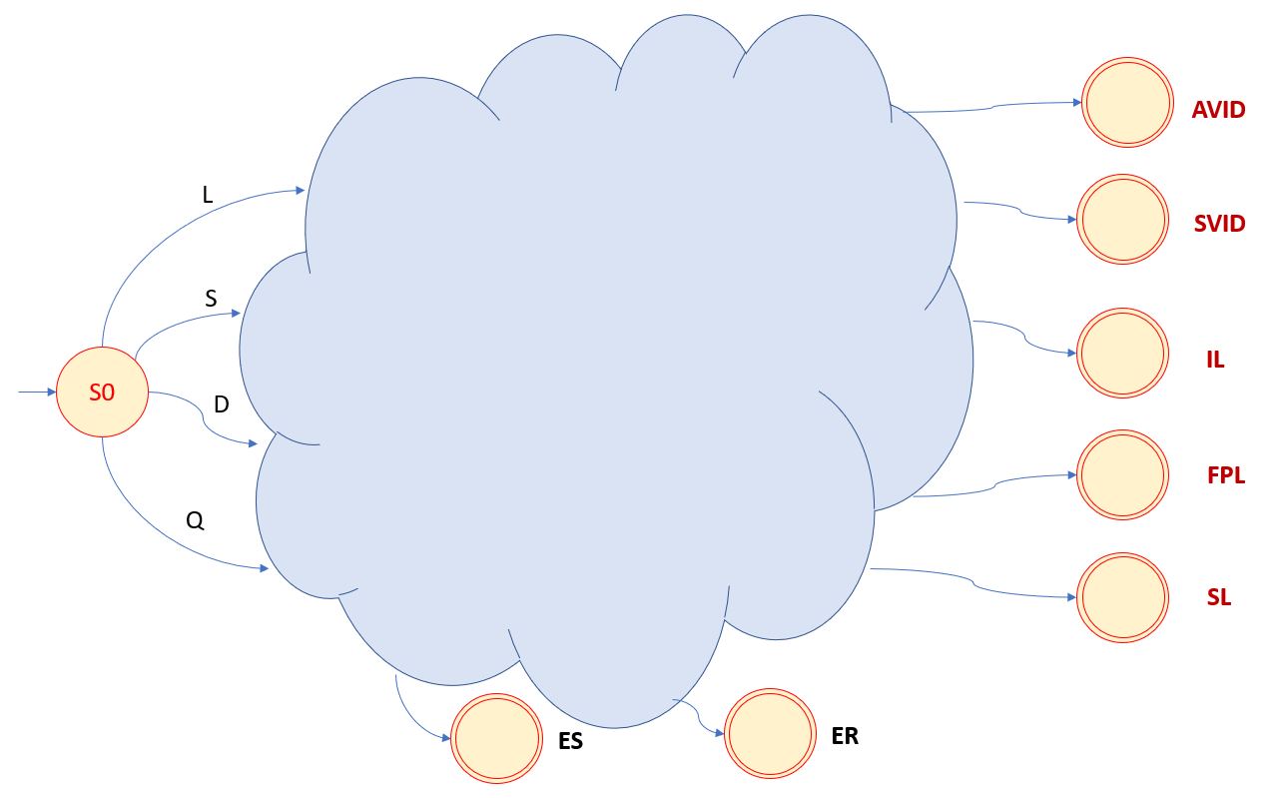

Where:
- AVID: Final state that recognizes arithmetic variable identifier.
- SVID: Final state that recognizes string variable identifier.
- IL: Final state that recognizes integer literals.
- FPL: Final state that recognizes float point literals.
- SL: Final state that recognizes string literals
- ES: Error state that does not retract.
- ER: Error state that retracts.
Suggestion: Use MS Video or PowerPoint to create the diagram (you can create an additional space to include the image / picture here).

Answer:
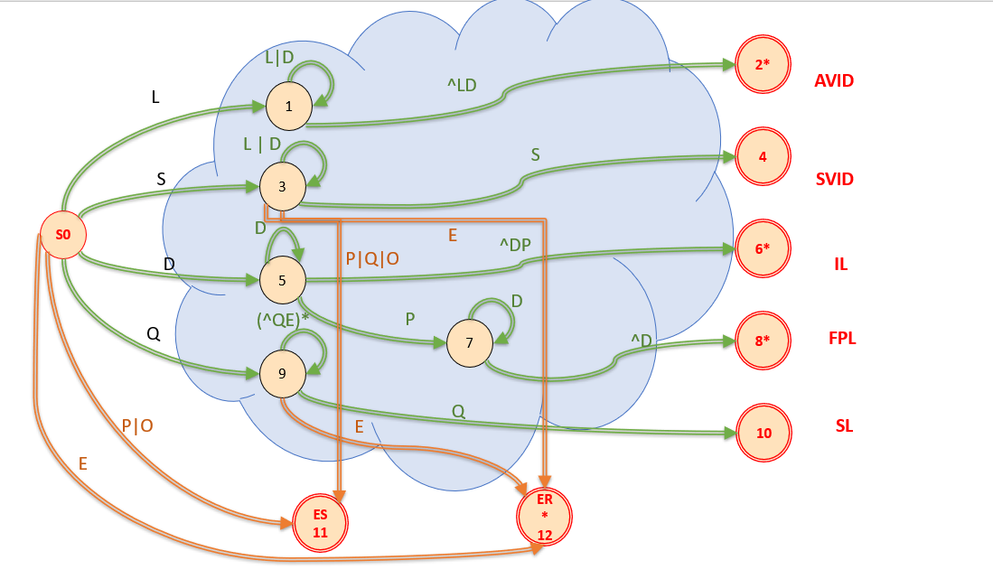

PART 3: TT – Transition Table (2 marks)

Activity: Complete the following table that defines the DFA for Platypus 2,0:

State | L | D | P | S | Q | E | O | Type
0 | 1 | 5 | ES | 3 | 9 | ER | ES | NOAS
1 | 1 | 1 | 2 | 2 | 2 | 2 | 2 | NOAS
2 | IS | IS | IS | IS | IS | IS | IS | ASWR
3 | 3 | 3 | ES | 4 | ES | ER | ES | NOAS
4 | IS | IS | IS | IS | IS | IS | IS | ASNR
5 | 6 | 5 | 7 | 6 | 6 | 6 | 6 | NOAS
6 | IS | IS | IS | IS | IS | IS | IS | ASWR
7 | 8 | 7 | 8 | 8 | 8 | 8 | 8 | NOAS
8 | IS | IS | IS | IS | IS | IS | IS | ASWR
9 | 9 | 9 | 9 | 9 | 10 | ER | 9 | NOAS
10 | IS | IS | IS | IS | IS | IS | IS | ASNR
11 | IS | IS | IS | IS | IS | IS | IS | ASNR
12 | IS | IS | IS | IS | IS | IS | IS | ASWR

Use the following representation to this table:
- For input symbols (quotations) – columns L, D, P, S, Q, E, O:
  - Numbers = For indicate states (from 0 to 12)
  - ES = Error state (no retract)
  - ER = Error state with retract
- For input symbols (double quotes) – column Type:
  - Accepting state type = ASWR (with retract) or ASNR (no retract)

- For state type:
  - AVID (arithmetic variable identifier)
  - SVID (string variable identifier)
  - IL (integer literal)
  - FPL (floating point literal)
  - SL (string literal)

Update: 1st Jan 2021.

Adapted from resources developed by Prof. Svillen Ranev (Algonquin College, 2019)

